C372 Graded Assignment Project Report

Project Title
Team members | - <Student ID> <Student Name> <Student Role>  - <24028856><Chan Xin Yi><student role>  - <24026442><Ho Sheng Wei Keane><Student Role>  - <24039614><Huang Yule><student role>  - <2404360> <Justin Wong> <Member>  - <24003425><Kang Wei Jie><student role>
Class | E63C

Table of Contents
Project Overview 3
System Design 4
Use Case Diagram 4
Prototype 4
Entity Relationship Diagram 4
Functional Requirements 5
Project Schedule, Milestones, and Work Allocation 6
Project Timeline 6
Team Contribution Planner 8

Project Overview
Provide a concise description of the system being developed and its main purpose. This section should include:
- An analysis of market gaps for the chosen product or service, along with the proposed solution to address them.
- Identification of relevant regulatory and compliance requirements (e.g., PCI DSS, AML/KYC, MAS guidelines).
-------------------------------------------------------------------------------------------------------------------------------------
Project Title: HealthEase – Affordable Health Product Platform
Market Gap:
Many low-income families and individuals in Southeast Asia struggle to access affordable, verified health products such as vitamins, masks, and basic medication.
Offline pharmacies may charge high prices, while online stores often lack secure, low-cost digital payment options for unbanked users.
Identified Pain Points:
- High markup on essential healthcare items.
- Limited access to credit or digital wallets.
- Fear of fraud when purchasing from unverified sellers.
- Complex payment steps or foreign-currency issues for cross-border orders.
Proposed Solution:
“HealthEase” – an e-commerce web platform offering affordable, verified health products from trusted suppliers.
It supports a built-in digital wallet for top-ups and micro-transactions, with secure, low-fee payments for underserved groups.
Target Audience / Underserved Groups
- Low-income households.
- Elderly individuals relying on caregivers.
- Migrant workers sending health supplies home.
- Rural communities with limited banking access.

Regulatory Requirements
Area | Description | Example Guideline
Data Security | Protect customer data & transactions | MAS Technology Risk Management (TRM)
Payment Security | Encrypt card info & comply with standards | PCI DSS
AML / KYC | Verify wallet users and flag suspicious transactions | MAS Notice 626, AML Act
Consumer Protection | Display accurate product info and pricing | Consumer Protection (Fair Trading) Act (SG)

System Design
This section should include the key design components of your system:
- Use Case Diagram – to illustrate the system’s main functions and interactions between users and the system.
- Prototype – to showcase the preliminary user interface and workflow of the system.
- Entity Relationship Diagram (ERD) – to model the data structure and relationships between key entities.

Use Case Diagram
Paste or attach the project UCD here

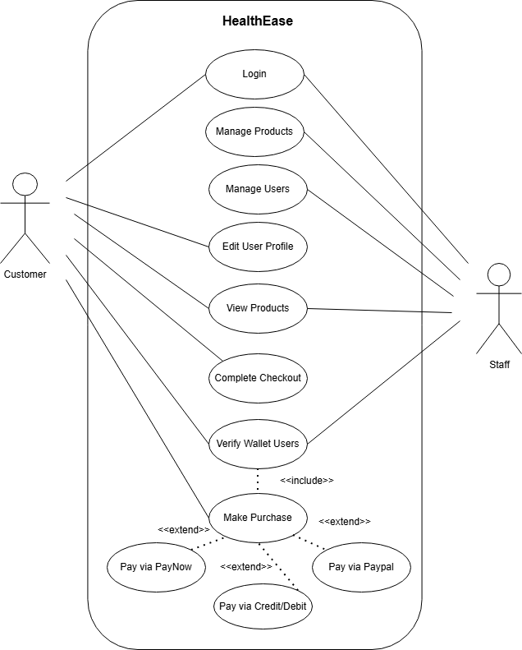

Prototype
Attach the project prototype here

Entity Relationship Diagram
Paste or attach the project ERD here

Functional Requirements
This section outlines the specific features and functionalities that the system must provide. It should clearly describe what the system is expected to do to meet user needs and project objectives.
-------------------------------------------------------------------------------------------------------------------------------------
Functional Requirements
The following functional requirements describe how HealthEase will meet the core needs of users and administrators during Part 1 of development.
- Visitors can browse products and services.
  - Visitors will be able to view a catalogue of affordable health products such as vitamins, supplements, and masks.
  - The product listing page will display essential details like name, price, image, and stock availability.
  - Filtering and search features will allow users to find products easily based on category or price range.
- Customers can sign up and log in securely.
  - New users can register an account using their email address and password.
  - Passwords will be stored securely using hashing.
  - Returning users can log in to access their profile, saved cart, and order history.
  - Two-factor authentication (2FA) may be implemented for added security.
- Customers can manage their shopping cart.
  - Logged-in users can add products to the cart, update quantities, or remove items.
  - The system will automatically update the total cost as quantities change.
  - Cart contents will be saved in the database so users can retain their cart even after logging out.
- Administrators can manage product details.
  - Admin users will have access to an admin dashboard to perform CRUD operations on products.
  - They can add new products, edit existing ones (price, description, image, stock), and delete discontinued items.
  - The interface will validate all inputs before saving changes to the database.
- Front-end and back-end validations are implemented.
  - All forms (login, registration, product management, and checkout) will validate inputs before submission.
  - Invalid or incomplete data (e.g., missing fields, wrong formats) will be rejected.
  - Server-side validation will ensure that only clean and verified data are stored in the database.
- Customer experience and navigation.
  - Users can easily navigate between product pages, cart, and checkout.
  - The layout will be intuitive and mobile-friendly to ensure accessibility for all users.

Project Schedule, Milestones, and Work Allocation
This section should provide a detailed breakdown of the project timeline, key milestones, and the specific tasks assigned to each team member. Careful planning is required, as each member will be assessed individually based on their contribution, effort, and teamwork. This section also serves as a reference for both the team and supervisor to monitor project progress.

Project Timeline
Discuss with your team and plan your milestones/tasks. Below some samples are filled in.
Week | Milestone/Task | Description/Deliverables | Responsible Member | Status
1 | Project Initiation | Define project scope, goals, and team roles.  Conduct initial research on market gaps and target users. | Entire Team | Completed
2 | System Design and Planning | System Design  - UCD  - Functional Requirements  Planning  - Allocation of features - Team Contribution Planner | System Design  - Entire team  Planning  - Member 1 work on feature 1 prototype  - Member 2 work on feature 2 prototype… | Completed

3 | Prototype Development | - Feature 1  - Feature 2  - …  - Compile features | - Member 1 work on feature 1  - Member 2 work on feature 2  - …. | Work in progress
4
5
6
7
8
9
10
11
12
13 | Presentation week

Team Contribution Planner
As part of your project planning, your team is required to complete the table below. A sample is shown. This helps ensure a clear division of responsibilities and provides clarity during your presentation. You should also include the team’s GitHub repository and deployment URLs. The completed table must be included as part of your final submission.
Note:
- Every team member must contribute to coding. Do not assign any member solely to documentation or UI styling.
- A team member may be responsible for more than one feature. You may add extra rows under the same name if needed.

Sample:
Member Name and Role (Leader/Member/Scribe) | Member GitHub username | Feature Assigned | Description of Work | Route(s) Used | Models, Views and Controllers
Student Full Name (Student ID) - Role | GitHub username | The main feature/function the student is responsible for. | Describe what you worked on for this feature. | The Express route(s) created or handled:  E.g. /yourRouteHere | List the models, views and controllers used
Mary Tan (24012345) - Leader | mary_tan | Student management | Prototype for students  Created full CRUD for students management, views, search, filter, validation of input  Integrated whole project | /students  /student/:id  /students/add  /student/:id/update  /student/:id/delete  /student/search/:keyword | Models:  Student.js  Views:  Student.ejs  addStudent.ejs  editStudent.ejs  Controllers:  StudentController.js
Peter Lim (24112345) –  Member | peter_lim | Module management | Prototype for modules  Created full CRUD for modules management, views, search, filter, validation of input  Came up with the design, look and feel of the website | /modules  /module/:code  /module/add  /module/:code/update  /module/:code/delete  /module/search/:keyword | Models:  Module.js  Views:  Module.ejs  addModule.ejs  editModule.ejs  Controllers:  ModuleController.js

As a team, complete the table below

Project Description:
GitHub repository:
Deployment URL:

Member Name and Role (Leader/Member) | Member GitHub username | Feature Assigned | Description of Work | Route(s) Used | Models, Views and Controllers
Keane | Keanehsw | Register  Login | Create Register and Login page | /register  /login  /logout | Models:  User.js  Views:  user.ejs  adduser.ejs  edituser.ejs  Controllers:  userController.js
xinyi |  | Shopping cart  Updating item  Add new item
Justin | Jw69ine | 2FA, Payment?
yule | jlkwl | Edit product, delete product, Update product

